**FINAL REPORT**

**Capstone Project - The Battle of Neighbourhoods -**

**“French Restaurants in New York”**

**Introduction:**

[New York City](https://en.wikipedia.org/wiki/New_York_City)'s demographics show that it is a large and [ethnically diverse](https://en.wikipedia.org/wiki/Multiculturalism) [metropolis](https://en.wikipedia.org/wiki/Metropolis). It is the largest city in the [United States](https://en.wikipedia.org/wiki/United_States) with a long history of international [immigration](https://en.wikipedia.org/wiki/Immigration). New York City was home to over 8.3 million people in 2019, accounting for over 40% of the population of [New York State](https://en.wikipedia.org/wiki/New_York_State) and a slightly lower percentage of the [New York metropolitan area](https://en.wikipedia.org/wiki/New_York_metropolitan_area), home to approximately 23.6 million.

New York City has also been a major point of entry for immigrants; the term "melting pot" was coined to describe densely populated immigrant neighbourhoods on the Lower East Side. As many as 800 languages are spoken in New York, making it the most linguistically diverse city in the world.

**French Population in New York**

The French Embassy estimates that about 75,000 French citizens live in the New York metropolitan area, and since the early aughts, the French community in the city has seen an increase of about 45 percent. Those figures may be overblown, but the Frenchification of Brooklyn is impossible to deny. Today, over 60,000 French citizens and over 81,000 French speakers live in New York, but have no such hub. No wonder French is the fourth most spoken language in New York.

New Yorkers are extreme Francophiles : they love French culture, food, cinema; they associate it with a certain art de vivre, a quality of life that is reflected in art, fashion and gastronomy.

The French presence is truly felt through the hundreds of French shops and restaurants that mark the City’s landscape.

**Problem:**

The objective is to locate and recommend which neighbourhood in New York City will be best choice to start a new French restaurant.

1) List and visualize all major parts of New York City that has great French restaurants.

2) what is best location in New York City for French Cuisine?

3) which areas have potential French Restaurant Market?

4) which all areas lack French Restaurants?

5) which is the best place to stay if you prefer French Cuisine?

**Data Section:**

New York City's demographics show that it is a large and ethnically diverse metropolis. With its diverse culture, comes diverse food items. There are many restaurants in New York City, each belonging to different categories like Chinese, Indian, and French etc.

For this project we need the following data:

* New York City data that contains list Boroughs, Neighbourhoods along with their latitude and longitude.

- Data source : <https://cocl.us/new_york_dataset>

- Description: This data set contains the required information. And we will use this data set

to explore various neighbourhoods of New York City

* French restaurants in each neighbourhood of New York City.
* Data source: Foursquare API
* Description: By using this API we will get all the venues in each neighbourhood. We can filter these venues to get only French restaurants.
* GeoSpace data
* Data source : <https://data.cityofnewyork.us/City-Government/Borough-Boundaries/tqmj-j8zm>
* Description: By using this geo space data we will get the New York Borough boundaries that will help us visualize choropleth map.

**Methodology:**

1. We begin by collecting the New York city data from the following link "[https://cocl.us/new_york_dataset"](https://cocl.us/new_york_dataset%22)
2. We will find all venues for each neighbourhood using Foursquare API

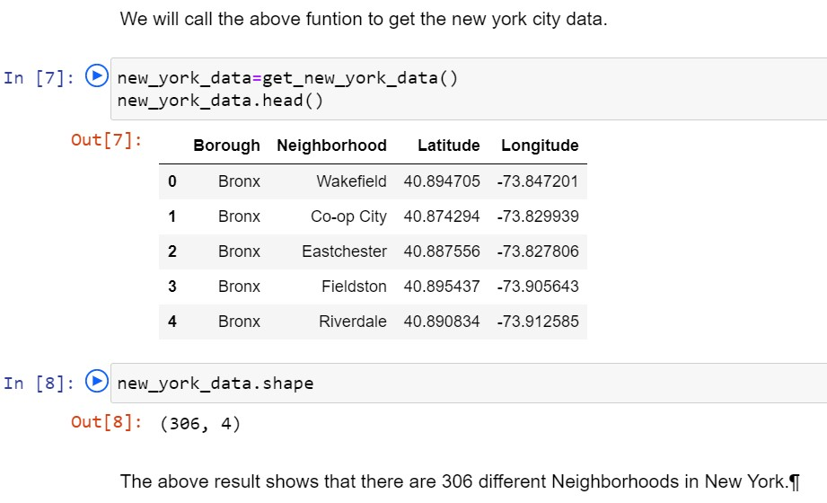

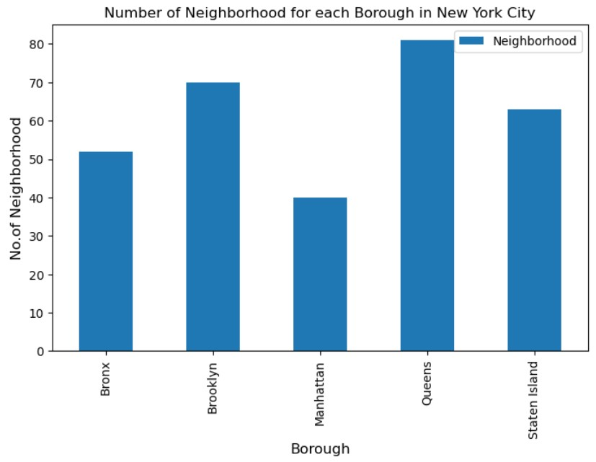

1. We will then filter out all venues with Indian restaurant for further analysis.

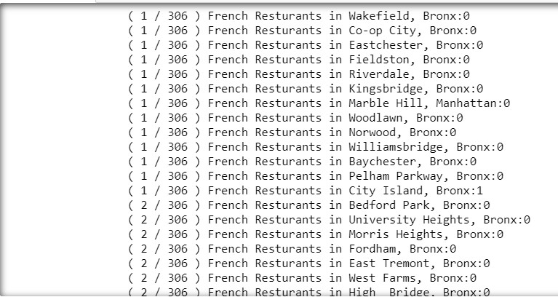

1. Next using Foursquare API, we will find the Ratings, Tips, and Number of Likes for all the French Restaurants.

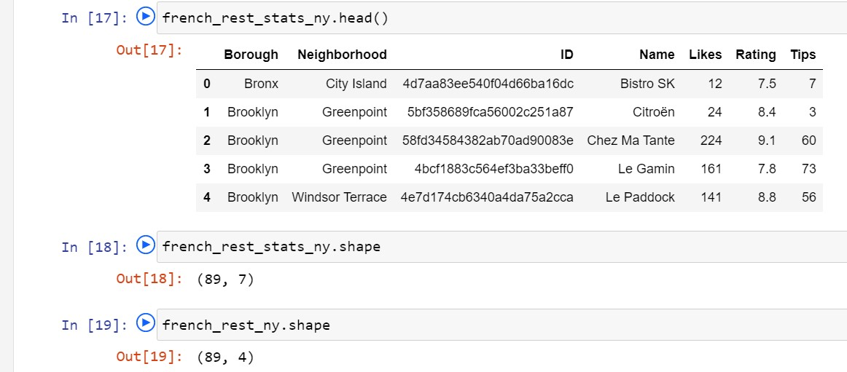

1. We will then sort Neighbourhoods and Borough the data keeping Ratings as the constraint, in this example we chose 8.0 for rating.

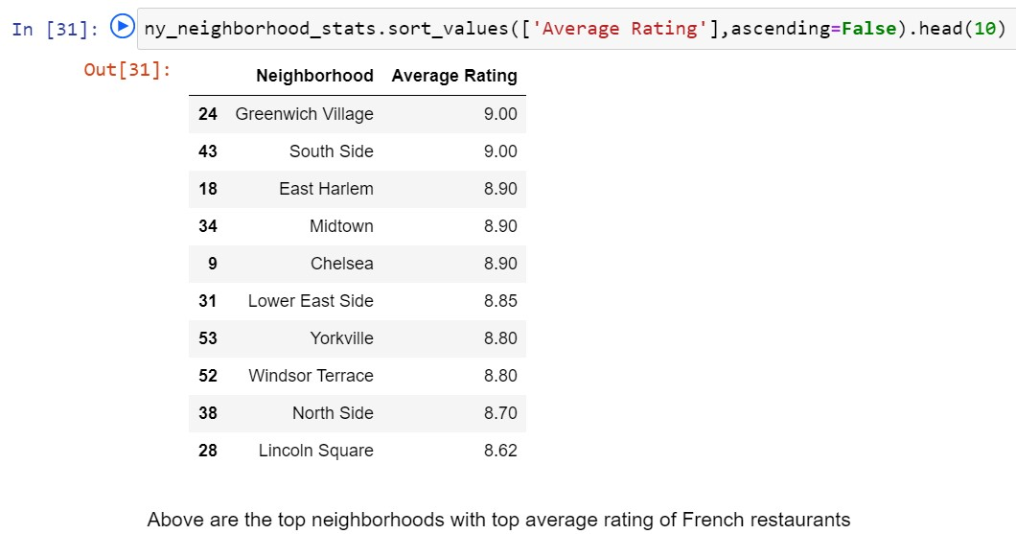

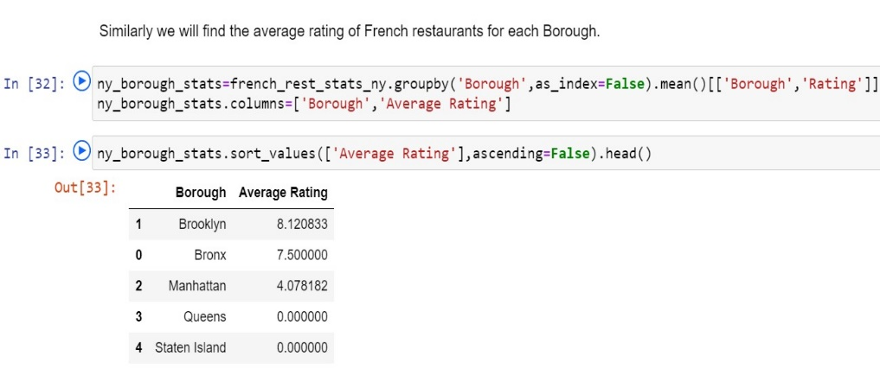

1. 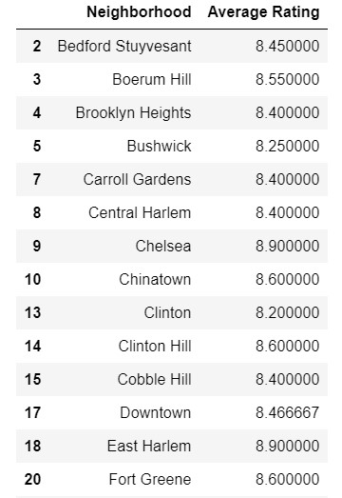Next, we will consider all the neighbourhoods with average rating greater or equal 8.0 to visualize on map.
2. We will join this dataset to original New York data to get longitude and latitude.

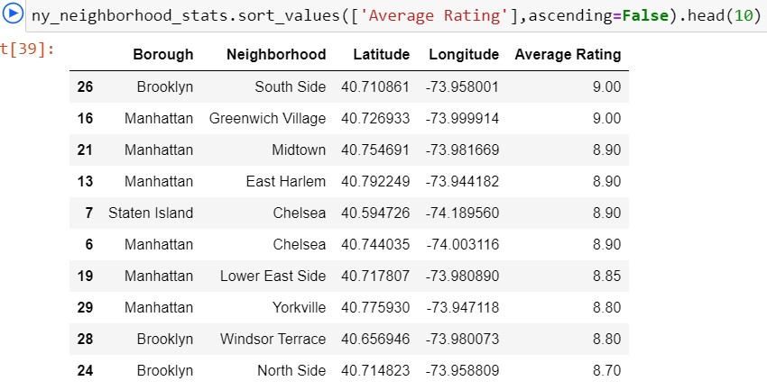

1. Finally, we will visualize the Neighbourhoods and Borough based on average Rating using python’s Folium library.

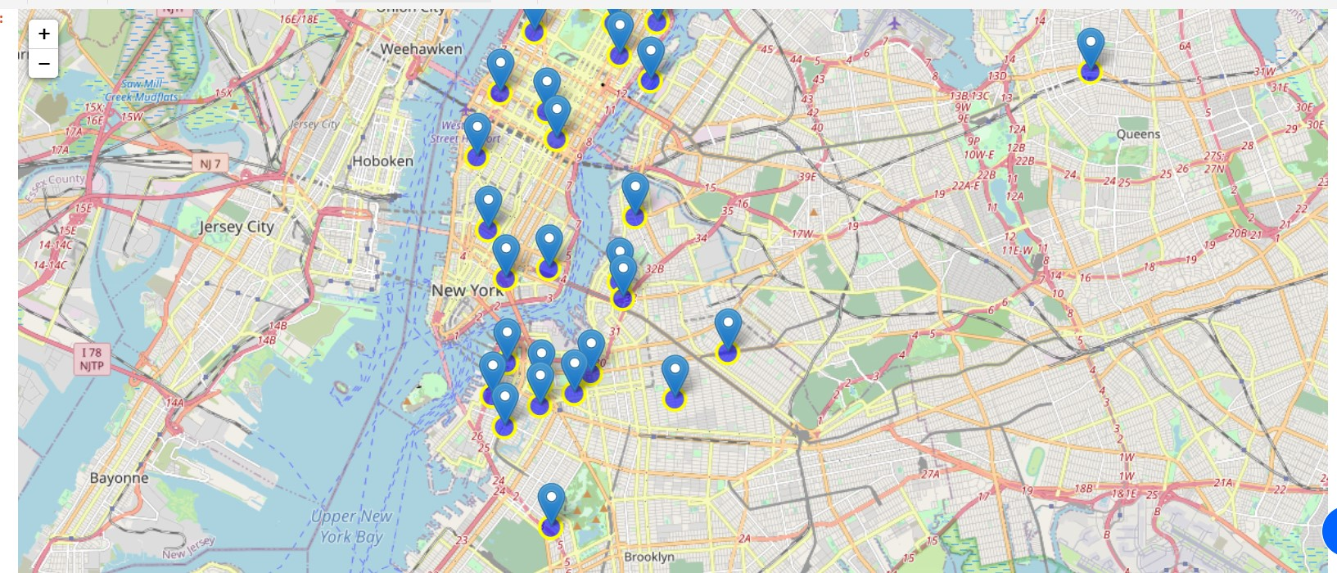Neighbourhoods based on average rating:

**Result:**

So now we can answer the questions asked above in the Questions section:

1. The following location in New York City has great French restaurants.



#### Manhattan, Brooklyn and Bronx are the best Borough for French cuisine and The Queens and Staten Island have few French restaurant.

#### Manhattan have the best potential French Restaurant Market.

#### Brooklyn has the best likes and ratings for French Restaurants.

#### Both Manhattan and Brooklyn are the best place to stay if you prefer French Cuisine.

**Conclusion:**

There is always room for improvement and hence the above solution I have provided can also be improved for best results depending on the data we have.